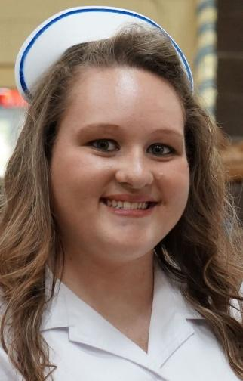

This $1,000 scholarship will be given each year
to honor the memory of Brittany Miranda Lee-
LPN at Bonifay Nursing and Rehabilitation.

To be eligible, applicants must be a graduating senior at Holmes County High School.
Primary eligibility will be given to students seeking a career in Nursing-
Licensed Practical Nurse (LPN) or Registered Nurse (RN).
Secondary eligibility will be considered for students seeking a career in the medical field.
Award check will be made payable to a college of the recipient’s choice.

APPLICATION DEADLINE IS ___________________MAY 1, 2026___________________
Contact Information
Applicant Name: _____________________________________________________________________
Mailing Address: _____________________________________________________________________
Phone Number: ______________________________________________________________________
Email Address: _______________________________________________________________________
Parent/Guardian Name & Phone Number: __________________________________________________________

Background
Are you a senior at Holmes County High School? Yes No
What is your cumulative GPA? Unweighted _______ Weighted _______
Are you pursuing a nursing career? Yes No
Which field do you plan to enter? (Licensed Practical Nursing-LPN or Registered Nurse-RN)
_____________________________________________________________________________________
What college do you anticipate attending (full name, no abbreviations)?
_____________________________________________________________________________________
List any extracurricular activities or community organizations in which you are involved:
_____________________________________________________________________________________
_____________________________________________________________________________________
Brief Essay
Briefly tell us what inspired you to enter your chosen field and how this scholarship can help you achieve that goal. If necessary, you may attach a separate sheet of paper to this application with your answer.
_____________________________________________________________________________________
_____________________________________________________________________________________
_____________________________________________________________________________________
_____________________________________________________________________________________
_____________________________________________________________________________________
_____________________________________________________________________________________
_____________________________________________________________________________________
_____________________________________________________________________________________
_____________________________________________________________________________________
_____________________________________________________________________________________

Brittany was a 2015 graduate of Holmes County High School and began nursing school shortly after graduation. She graduated as LPN in July 2016 and began her career at Bonifay Nursing and Rehabilitation Center. Brittany cared deeply for her residents at BNRC and strived to provide them with excellent care and compassion. Her residents were like family to her, and she grew to love them dearly, along with their families.
Brittany was diagnosed with Type 1 Diabetes and Hashimoto’s Disease; both autoimmune diseases wreak havoc on a person that no one can see on the outside. Due to the toll that these diseases took on her, she passed from this life and went to be with our Lord in heaven on August 19, 2025, at the young age of 28.
Brittany loved her family and her Jeep (Bandit) along with all her animals and reptiles. She had a zest for life and enjoyed the simple things with family. We hope that this scholarship will help someone who has a similar zest for life and compassion that they can show to the patients and families they will care for when they venture into their career of nursing.
